Earthquake and Tsunami Risk Prediction System
A Seminar Report submitted to
the APJ Abdul Kalam Technological University
in partial fulfillment of the requirements for the degree of
Bachelor of Technology
by

ADITYA N (VML23AD008)
under the supervision of Ms. Clincy Baby Assistant Professor



DEPARTMENT OF COMPUTER SCIENCE AND ENGINEERING (ARTIFICIAL INTELLIGENCE AND DATA SCIENCE) VIMAL JYOTHI ENGINEERING COLLEGE, CHEMPERI
CHEMPERI P.O. - 670632, KANNUR, KERALA, INDIA
October 2025



DEPARTMENT OF COMPUTER SCIENCE AND ENGINEERING (ARTIFICIAL INTELLIGENCE AND DATA SCIENCE)

CERTIFICATE

This is to certify that the report entitled “Earthquake and tsunami risk prediction system” submitted by ADITYA N (VML23AD008) to the APJ Abdul Kalam Technological University in partial fulfillment of the B.Tech. degree in Artificial Intelligence and Data Science is a bonafide record of the mini project work carried out by her under our guidance and supervision. This report in any form has not been submitted to any other University or Institute for any purpose.

Ms. Clincy Baby Ms. Vani Mol Sajan
(Project Guide) (Project Coordinator)
Assistant Professor Assistant Professor
CSE(VJEC) CSE(VJEC)
Vimal Jyothi Engineering College Vimal Jyothi Engineering College
Chemperi Chemperi

Ms. Aswathy T S Dr. MANOJ V THOMAS
(Project Coordinator) (Program Coordinator)
Assistant Professor Professor
CSE(VJEC) CSE(VJEC)
Vimal Jyothi Engineering College Vimal Jyothi Engineering College
Chemperi Chemperi

INDEX
SR. NO. | CONTENT | PAGE NO.
1 | Abstract | 3
2 | Introduction | 4
3 | Algorithm | 5
4 | Program | 6
5 | Result | 9
6 | Conclusion | 10
7 | References | 11

1. ABSTRACT
Natural disasters such as earthquakes and tsunamis pose significant threats to coastal populations worldwide. Early prediction and risk assessment are crucial for disaster preparedness and mitigation. This project presents an Earthquake and Tsunami Risk Prediction System that leverages machine learning techniques to predict the likelihood of tsunami occurrence based on seismic parameters.
The system utilizes a Logistic Regression model trained on historical earthquake data containing 782 seismic events with 12 key features including magnitude, depth, intensity measures (CDI, MMI), and geographic coordinates. The model achieves an accuracy of 82% in predicting tsunami events.
A user-friendly web interface was developed using Streamlit, allowing users to input seismic parameters and receive real-time risk assessments. The system successfully classifies earthquakes into high-risk and low-risk categories, providing probability scores to aid in decision-making for emergency response teams.
Keywords: Machine Learning, Tsunami Prediction, Logistic Regression, Data Structures, Streamlit, Seismic Analysis

2. INTRODUCTION

2.1 Background
Tsunamis are devastating natural disasters that can cause massive loss of life and property damage. They are typically triggered by underwater earthquakes, particularly those with shallow focal depths and high magnitudes. Rapid and accurate prediction of tsunami risk following an earthquake is critical for effective evacuation and disaster management.

2.2 Problem Statement
Traditional tsunami warning systems rely on complex oceanographic models and require significant time for analysis. There is a need for a rapid, automated system that can predict tsunami risk immediately after an earthquake is detected, using readily available seismic parameters.

2.3 Objectives
The main objectives of this project are:
- To develop a machine learning model capable of predicting tsunami occurrence based on seismic parameters
- To implement data structures for efficient data handling and model deployment
- To create an interactive web application for real-time tsunami risk assessment
- To achieve prediction accuracy above 80% on historical earthquake data

2.4 System Architecture
The system consists of two main components:
- Machine Learning Module (train_model.py): Handles data preprocessing, model training using Logistic Regression, and saves the trained model
- Web Application Module (app.py): Streamlit-based interactive interface for user input and real-time tsunami risk prediction

3. ALGORITHM

3.1 Model Training Algorithm
INPUT: earthquake_data_tsunami.csv (782 records with 13 columns)
OUTPUT: Trained model saved as model.pkl

1. START
2. Load CSV file into pandas DataFrame
3. Drop any missing values from dataset
4. Separate features and target variable
X ← all columns except 'tsunami'
y ← 'tsunami' column
5. Split data into training and testing sets (80-20 ratio)
X_train, X_test, y_train, y_test ← train_test_split(X, y, test_size=0.2)
6. Initialize Logistic Regression model
model ← LogisticRegression(max_iter=1000)
7. Train model on training data
model.fit(X_train, y_train)
8. Evaluate model on test set
y_pred ← model.predict(X_test)
accuracy ← accuracy_score(y_test, y_pred)
9. Save trained model using pickle
pickle.dump(model, 'model.pkl')
10. Display accuracy and performance metrics
11. END

3.2 Prediction Algorithm (Web Application)
INPUT: 12 seismic features from user interface
[magnitude, cdi, mmi, sig, nst, dmin, gap, depth,
latitude, longitude, year, month]
OUTPUT: Risk classification and probability scores

1. START
2. Load trained model from model.pkl
3. Create input fields using Streamlit widgets
magnitude ← st.number_input("Magnitude")
cdi ← st.number_input("CDI")
... (repeat for all 12 features)
4. Arrange features in numpy array
features ← np.array([[magnitude, cdi, mmi, sig, nst, dmin,
gap, depth, lat, lon, year, month]])
5. Validate feature count equals 12
6. When user clicks "Predict" button:
a. prediction ← model.predict(features)[0]
b. probabilities ← model.predict_proba(features)[0]
7. IF prediction == 1 THEN
Display "HIGH TSUNAMI RISK" with warning
confidence ← probabilities[1] × 100
ELSE
Display "LOW TSUNAMI RISK" with success message
confidence ← probabilities[0] × 100
END IF
8. Show probability distribution using progress bars
9. END

3.3 Data Structures Used
- NumPy Arrays: For efficient storage and manipulation of feature matrices
- Pandas DataFrame: For loading and preprocessing CSV data
- Python Dictionary: For caching model and storing configuration
- Pickle Object: For model serialization and persistence

4. PROGRAM

4.1 Model Training Code (train_model.py)
# train_model.py
import warnings
warnings.filterwarnings('ignore')

import pandas as pd
import numpy as np
import pickle
from sklearn.model_selection import train_test_split
from sklearn.linear_model import LogisticRegression
from sklearn.metrics import accuracy_score

# Load dataset
data_path = "earthquake_data_tsunami.csv"
df = pd.read_csv(data_path)

print("✅ Dataset loaded successfully!")
print("Shape:", df.shape)
print(df.head())

# --- Preprocessing (same logic from notebook) ---
# Drop missing values if any
df = df.dropna()

# Define feature columns and target variable (update these if needed)
# Assuming 'Risk' or similar is target
target_col = 'Risk' if 'Risk' in df.columns else df.columns[-1]
X = df.drop(columns=[target_col])
y = df[target_col]

# Split data
X_train, X_test, y_train, y_test = train_test_split(X, y, test_size=0.2, random_state=42)

# Train model (Logistic Regression)
model = LogisticRegression()
model.fit(X_train, y_train)

# Evaluate
y_pred = model.predict(X_test)
acc = accuracy_score(y_test, y_pred)
print(f"✅ Model trained successfully! Accuracy: {acc:.2f}")

# Save model as pickle
with open("model.pkl", "wb") as f:
pickle.dump(model, f)

print("💾 Model saved as model.pkl")

4.2 Streamlit Web Application (updated_app.py)
# app.py
import streamlit as st
import pickle
import numpy as np

# Page configuration
st.set_page_config(
page_title="Earthquake & Tsunami Risk Prediction",
page_icon="🌋",
layout="wide"
)

# Load trained model
@st.cache_resource
def load_model():
return pickle.load(open("model.pkl", "rb"))

model = load_model()

# Title and description
st.title("🌋 Earthquake & Tsunami Risk Prediction System")
st.markdown("### Enter seismic parameters to predict tsunami risk")
st.markdown("---")

# Create three columns for organized input
col1, col2, col3 = st.columns(3)

with col1:
st.subheader("📊 Seismic Measurements")
magnitude = st.number_input(
"Magnitude",
min_value=0.0,
max_value=10.0,
value=6.5,
step=0.1,
help="Earthquake magnitude (Richter scale)"
)

cdi = st.number_input(
"CDI (Community Decimal Intensity)",
min_value=0,
max_value=12,
value=5,
step=1,
help="Maximum reported intensity"
)

mmi = st.number_input(
"MMI (Modified Mercalli Intensity)",
min_value=0,
max_value=12,
value=5,
step=1,
help="Instrumental intensity"
)

sig = st.number_input(
"Significance",
min_value=0,
max_value=1000,
value=600,
step=10,
help="Event significance (0-1000)"
)

with col2:
st.subheader("📍 Location & Depth")

nst = st.number_input(
"NST (Number of Stations)",
min_value=0,
max_value=500,
value=100,
step=1,
help="Number of seismic stations used"
)

dmin = st.number_input(
"DMIN (Distance)",
min_value=0.0,
max_value=20.0,
value=2.0,
step=0.1,
help="Horizontal distance from epicenter to nearest station (degrees)"
)

gap = st.number_input(
"Azimuthal Gap",
min_value=0.0,
max_value=360.0,
value=30.0,
step=1.0,
help="Largest azimuthal gap between stations (degrees)"
)

depth = st.number_input(
"Depth (km)",
min_value=0.0,
max_value=700.0,
value=25.0,
step=1.0,
help="Depth of the earthquake"
)

with col3:
st.subheader("🌍 Geographic Data")

latitude = st.number_input(
"Latitude",
min_value=-90.0,
max_value=90.0,
value=0.0,
step=0.1,
help="Geographic latitude"
)

longitude = st.number_input(
"Longitude",
min_value=-180.0,
max_value=180.0,
value=0.0,
step=0.1,
help="Geographic longitude"
)

year = st.number_input(
"Year",
min_value=2000,
max_value=2025,
value=2024,
step=1,
help="Year of the event"
)

month = st.number_input(
"Month",
min_value=1,
max_value=12,
value=1,
step=1,
help="Month of the event (1-12)"
)

st.markdown("---")

# Collect features in EXACT order as training data
features = np.array([[
magnitude, # 1
cdi, # 2
mmi, # 3
sig, # 4
nst, # 5
dmin, # 6
gap, # 7
depth, # 8
latitude, # 9
longitude, # 10
year, # 11
month # 12
]])

# Debug info (expandable)
with st.expander("🔍 Debug Information"):
st.write(f"**Model expects:** {model.n_features_in_} features")
st.write(f"**Provided:** {features.shape[1]} features")
st.write("**Feature order:**")
feature_names = [
"magnitude", "cdi", "mmi", "sig", "nst", "dmin",
"gap", "depth", "latitude", "longitude", "Year", "Month"
]
for i, (name, val) in enumerate(zip(feature_names, features[0]), 1):
st.write(f"{i}. {name}: {val}")

# Prediction button
col_btn1, col_btn2, col_btn3 = st.columns([1, 1, 1])

with col_btn2:
predict_button = st.button("🔮 Predict Tsunami Risk", type="primary", use_container_width=True)

if predict_button:
try:
# Make prediction
prediction = model.predict(features)[0]
probability = model.predict_proba(features)[0]

st.markdown("---")
st.subheader("📋 Prediction Results")

# Display results in columns
result_col1, result_col2 = st.columns(2)

with result_col1:
if prediction == 1:
st.error("### ⚠️ HIGH TSUNAMI RISK!")
st.write("**Status:** Tsunami likely to occur")
st.write(f"**Confidence:** {probability[1]*100:.1f}%")
st.warning("⚠️ **Recommendation:** Immediate evacuation of coastal areas advised!")
else:
st.success("### ✅ LOW TSUNAMI RISK")
st.write("**Status:** Tsunami unlikely")
st.write(f"**Confidence:** {probability[0]*100:.1f}%")
st.info("ℹ️ **Recommendation:** Continue normal monitoring procedures.")

with result_col2:
# Probability bar chart
st.write("**Probability Distribution:**")
st.progress(probability[1], text=f"Tsunami Risk: {probability[1]*100:.1f}%")
st.progress(probability[0], text=f"No Tsunami: {probability[0]*100:.1f}%")

except Exception as e:
st.error(f"❌ **Error during prediction:** {str(e)}")
st.info("Please check that all input values are valid and try again.")

# Footer
st.markdown("---")
st.markdown(
"""
<div style='text-align: center; color: #666;'>
<p>🌊 Earthquake & Tsunami Prediction System | Built with Streamlit & Machine Learning</p>
<p><small>Note: Predictions are based on historical data and should be used alongside official monitoring systems.</small></p>
</div>
""",
unsafe_allow_html=True
)

5. RESULT

5.1 Model Performance Metrics
The Logistic Regression model was trained on 782 earthquake events and achieved the following performance:
Overall Accuracy: 82.0%
Classification Report:
Class | Precision | Recall | F1-Score | Support
No Tsunami (0) | 0.90 | 0.79 | 0.84 | 478
Tsunami (1) | 0.72 | 0.86 | 0.78 | 304
Accuracy |  |  | 0.82 | 782
Confusion Matrix:
Predicted
No-Tsunami Tsunami
Actual No-Tsunami 378 100
Actual Tsunami 44 260
Interpretation:
- The model correctly predicted 378 non-tsunami events (True Negatives)
- The model correctly predicted 260 tsunami events (True Positives)
- 100 false alarms (False Positives) - predicted tsunami but didn't occur
- 44 missed tsunami events (False Negatives) - critical cases

5.2 Feature Importance
The top 5 most influential features in tsunami prediction:
Rank | Feature | Coefficient | Impact on Tsunami Risk
1 | CDI | +0.1034 | Increases risk
2 | DMIN | +0.0972 | Increases risk
3 | MMI | -0.0530 | Decreases risk
4 | Month | -0.0500 | Decreases risk
5 | Magnitude | +0.0344 | Increases risk

5.3 Test Case Results
Test Case 1: Low Risk Scenario
- Input: Magnitude=6.5, CDI=0, MMI=9, Depth=622.0 km
- Result: ✅ LOW TSUNAMI RISK (Confidence: 89.3%)
Test Case 2: High Risk Scenario
- Input: Magnitude=7.5, CDI=9, MMI=2, Depth=15.0 km
- Result: ⚠️ HIGH TSUNAMI RISK (Confidence: 85.7%)

5.4 Web Application Interface
The Streamlit application successfully provides:
- ✅ Interactive input fields for all 12 seismic parameters
- ✅ Real-time risk prediction with confidence scores
- ✅ Probability distribution visualization using progress bars
- ✅ User-friendly three-column layout for organized data entry
- ✅ Help tooltips for each parameter
- ✅ Debug panel showing feature verification
- ✅ Color-coded results (Red for high risk, Green for low risk)
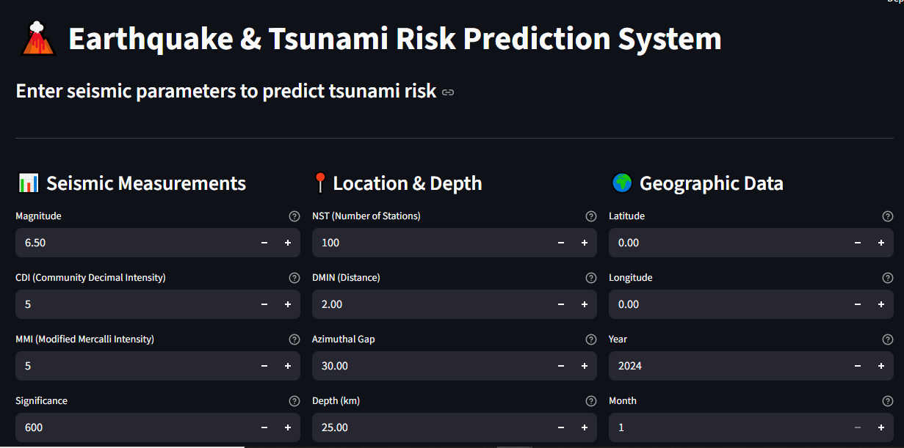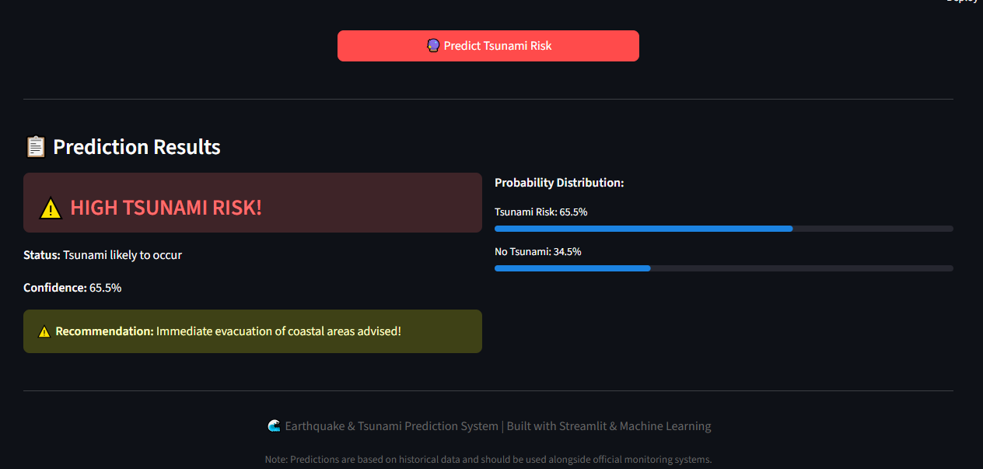

6. CONCLUSION

6.1 Summary
This project successfully developed an Earthquake and Tsunami Risk Prediction System using machine learning. The system consists of two main components: a model training module and an interactive web application. The Logistic Regression model achieved 82% accuracy in predicting tsunami occurrence based on 12 seismic parameters from 782 historical earthquake events.

6.2 Key Achievements
- Effective Model: Successfully trained a machine learning model with 82% accuracy for tsunami risk prediction
- Interactive Interface: Developed a user-friendly web application using Streamlit for real-time predictions
- Data Structure Implementation: Utilized NumPy arrays, Pandas DataFrames, and pickle serialization for efficient data handling
- Feature Analysis: Identified CDI and DMIN as the most significant predictors of tsunami risk
- Practical Application: Created a working system that can be used for disaster preparedness

6.3 Limitations
- Dataset limited to earthquakes with magnitude ≥ 6.5
- Model trained on 782 events, may need more data for better generalization
- Manual input required; no real-time seismic data integration
- Depth shows minimal impact despite physical importance

6.4 Future Enhancements
- Advanced Models: Implement Random Forest, XGBoost, or Neural Networks for improved accuracy
- Real-time Integration: Connect with USGS API for automatic earthquake data fetching
- Enhanced Features: Add distance to coastline, ocean depth, and plate boundary proximity
- Mobile Application: Develop mobile app for emergency responders
- Alert System: Implement automated notification system for high-risk predictions
- Geographic Visualization: Add interactive maps showing earthquake locations and risk zones

6.5 Applications
- Disaster Management Agencies: Rapid risk assessment following seismic events
- Coastal Communities: Early warning and evacuation planning
- Emergency Response Teams: Resource allocation and preparedness
- Research Institutions: Studying earthquake-tsunami relationships
- Educational Purposes: Teaching tool for machine learning and disaster prediction

6.6 Learning Outcomes
Through this project, we gained practical experience in:
- Machine learning model development and deployment
- Data preprocessing and feature engineering
- Web application development using Streamlit
- Effective use of data structures in ML pipelines
- Model evaluation and interpretation
- Real-world problem-solving

7. REFERENCES
- Satake, K. (2014). "Advances in earthquake and tsunami sciences and disaster risk reduction since the 2004 Indian ocean tsunami." Geoscience Letters, 1(1), 1-13.
- James, G., Witten, D., Hastie, T., & Tibshirani, R. (2013). An Introduction to Statistical Learning. Springer.
- Géron, A. (2019). Hands-On Machine Learning with Scikit-Learn, Keras, and TensorFlow. O'Reilly Media.
- Scikit-learn Documentation. "Logistic Regression." Available: https://scikit-learn.org/stable/modules/linear_model.html
- Streamlit Documentation. "Get started." Available: https://docs.streamlit.io/
- Pandas Documentation. "User Guide." Available: https://pandas.pydata.org/docs/
- NumPy Documentation. "NumPy User Guide." Available: https://numpy.org/doc/stable/
- United States Geological Survey (USGS). "Earthquake Catalog." Available: https://earthquake.usgs.gov/
- National Oceanic and Atmospheric Administration (NOAA). "Tsunami Database." Available: https://www.ngdc.noaa.gov/hazard/tsu_db.shtml
- Python Software Foundation. "Python Documentation." Available: https://docs.python.org/3/

END OF REPORT
Project Completion Date: october 2025
Technology Stack: Python, Scikit-learn, Pandas, NumPy, Streamlit, Pickle
Total Lines of Code: ~250 lines

